Acknowledgement
I am over helmed in all humbleness and gratefulness to acknowledge my depth to all those who helped me to put these ideas, well above the level of simplicity and into something concrete.
I would like to express my special thanks of gratitude to my Computer Science Teacher Mr. Shahbaz Ali for his guidance and constant motivation and help. I would also like to thank my parents and friends for helping me completing this project within the limited time. I am making this project not only for marks but also to increase my knowledge.
Thanks again to all who have helped me.
.
Class: XII-PC
Introduction

Employee Records Management System is very beneficial to perform Employee Management related tasks easily and efficiently. It saves a lot of time by performing tasks in the system rather than maintaining registers.

It assists to keep track of employee’s information such as salary details, medical related information, attendance and much more.

The recommended software and hardware requirements are easily available. Maintaining registers for this can be a complex task. Employee Record Management System is an error free, secure, reliable management system. Thus, it will help organization in better utilization of resources. The organization can maintain computerized records without redundant entries. That means no one need not to be distracted by information that is not relevant, while being able to reach the information.

Hardware and Software
Used:
Hardware:
- PROCESSOR – Intel i5-4210U CPU @ 1.70GHz 2.40GHz
- RAM – 4GB
- OS – WINDOWS 10
- STORAGE – 500GB SSHD
- PRINTER – To Print the Required Documents
Software:
- Python 3.10.8
- MySQL 8.0.3
- Microsoft Word 365 (Output Presentation)
Recommended:
Hardware:
- PROCESSOR – PENTIUM DUAL CORE
- RAM – 2GB
- OS – WINDOWS 7(SERVICE PACK 1) OR WINDOWS 10
- STORAGE – 80GB
Software:
- Python 3.2 or Later
- MySQL 5.6 or Later
- Microsoft Word 2007 or Later
- Pen drive/Compact Disc (CD)
Modules
- OS Module
The python OS module provides function used for interacting with the operating system and get related information about it.

- RE Module
Short name – regular expression, is used for various string patterns-that is the regex-a string to search against and return a result usually a Match object.

- MYSQL-Connector
MySQL Connector enables python program to access MySQL databases.

Coding
#Importing Required Modules for the program
from os import system
import re
#Importing mysql connector
import mysql.connector
#Creating database
def create_database():
con = mysql.connector.connect(host="localhost", user="root", password="224783")
c = con.cursor()
c.execute("CREATE DATABASE IF NOT EXISTS EMPLOYEE;")
create_database()
#Creating table
def create_table():
con = mysql.connector.connect(host="localhost", user="root", password="224783", database="Employee")
c = con.cursor()
c.execute("SHOW TABLES;")
data = c.fetchall()
for i in data:
if(i == ('empdata',)):
break
else:
c.execute("CREATE TABLE empdata(Id INT(11) PRIMARY KEY, Name VARCHAR(1000), Gender VARCHAR(7), Email_Id TEXT(1000), Phone_no VARCHAR(15), Address TEXT(1000), Post TEXT(1000), Salary BIGINT(20))")
create_table()
#Making Connection
con = mysql.connector.connect(host="localhost", user="root", password="224783", database="employee")
#Make a regular expression for validating an Email
regex = r'\b[A-Za-z0-9._%+-]+@[A-za-z0-9.-]+\.[A-Z|a-z]{2,}\b'

#Function to Add_Employ
def Add_Employ():
print("{:>60}".format("-->>Add Employee Record<<--"))
Id = input("Enter Employee Id: ")
#Checking If Employee Id is Exit or Not
if (check_employee(Id) == True):
print("Employee ID Already Exists\nTry Again...")
press = input("Press Any key to continue...")
Add_Employ()
Name = input("Enter Employee Name: ")
Gender = input("Enter Employee Gender: ")
Email_Id = input("Enter Employee Email : ")
if (re.fullmatch(regex, Email_Id)):
print("Valid Email, Please proceed")
else:
print("Invalid Email")
press = input("Press Any key to continue...")
menu()
Phone_no = input("Enter Employee Phone No: ")
Address = input("Enter Employee Address: ")
Post = input("Enter Employee Post: ")
Salary = input("Enter Employee Salary: ")
data = (Id, Name, Gender, Email_Id, Phone_no, Address, Post, Salary)
#Inserting Employee Details in empdata
sql = 'insert into empdata values(%s,%s,%s,%s,%s,%s,%s,%s)'
c = con.cursor()
c.execute(sql, data)
con.commit()
print("Successfully Added Employee Record")
press = input("Press Any Key to Continue...")
menu()

#Function to check if Employee with given Id exist or not
def check_employee(employee_id):
#query to select all rows from employee(empdata) table
sql = 'select * from empdata where Id=%s'
#making cursor buffered to make rowcount method work properly
c = con.cursor(buffered=True)
data = (employee_id,)
c.execute(sql, data)
#rowcount method to find number of rows with given values
r = c.rowcount
if r == 1:
return True
else:
return False

#Function to Display_Employ
def Display_Employ():
print("{:>60}".format("-->>Displaying All Employee Records<<--"))
#query to select all rows from Employee (empdata) Table
sql = 'select * from empdata'
c = con.cursor()
c.execute(sql)
#Fetching all details of all the Empoyees
r = c.fetchall()
for i in r:
print("*********************************")
print("Employee Id: ", i[0])
print("Employee Name: ", i[1])
print("Employee Gender: ", i[2])
print("Employee Email Id: ", i[3])
print("Employee Phone No: ", i[4])
print("Employee Address: ", i[5])
print("Employee Post: ", i[6])
print("Employee Salary: ", i[7]) print("**********************************")
print("\n")
press = input("Press Any key to continue...")
menu()

#Function to Update_Employ
def Update_Employ():
print("{:>60}".format("-->>Update Employee Record<<--"))
Id = input("Enter Employee Id: ")
#Checking If Employee Id is Exit or Not
if (check_employee(Id) == False):
print("Employee ID Does Not Exists\nTry Again...")
press = input("Press Any Key to Continue...")
menu()
else:
print("What do you want to Update? ")
print("1. Name")
print("2. Gender")
print("3. Email ID")
print("4. Phone No")
print("5. Address")
print("6. Post")
print("7. Salary")
ch = int(input("Enter your Update Preference Number from Above (1,2,3,4,5,6,7): "))
if ch == 1:
Name = input("Enter Employee Name: ")
sql = 'UPDATE empdata set Name = %s where Id = %s'
data = (Name, Id)
c = con.cursor()
c.execute(sql, data)
con.commit()
print("Updated Employee Name")
print("1. Want to Update more Records\n2. Go back to Menu")
cho = int(input("Press 1 or 2: "))
if cho == 1:
Update_Employ()
else:
menu()
elif ch == 2:
Gender = input("Enter Employee Gender: ")
sql = 'UPDATE empdata set Gender = %s where Id = %s'
data = (Gender, Id)
c = con.cursor()
c.execute(sql, data)
con.commit()
print("Updated Employee Gender")
print("1. Want to Update more Records\n2. Go back to Menu")
cho = int(input("Press 1 or 2: "))
if cho == 1:
Update_Employ()
else:
menu()
elif ch == 3:
Email_Id = input("Enter Employee Email ID: ")
if (re.fullmatch(regex, Email_Id)):
print("Valid Email, Please proceed")
else:
print("Invalid Email")
press = input("Press Any key to continue...")
menu()
sql = 'UPDATE empdata set Email_Id = %s where Id = %s'
data = (Email_Id, Id)
c = con.cursor()
c.execute(sql, data)
con.commit()
print("Updated Employee Email_Id")
print("1. Want to Update more Records\n2. Go back to Menu")
cho = int(input("Press 1 or 2: "))
if cho == 1:
Update_Employ()
else:
menu()
elif ch == 4:
Phone_no = input("Enter Employee Phone_no: ")
sql = 'UPDATE empdata set Phone_no = %s where Id = %s'
data = (Phone_no, Id)
c = con.cursor()
c.execute(sql, data)
con.commit()
print("Updated Employee Phone_no")
print("1. Want to Update more Records\n2. Go back to Menu")
cho = int(input("Press 1 or 2: "))
if cho == 1:
Update_Employ()
else:
menu()
elif ch == 5:
Address = input("Enter Employee Address: ")
sql = 'UPDATE empdata set Address = %s where Id = %s'
data = (Address, Id)
c = con.cursor()
c.execute(sql, data)
con.commit()
print("Updated Employee Address")
print("1. Want to Update more Records\n2. Go back to Menu")
cho = int(input("Press 1 or 2: "))
if cho == 1:
Update_Employ()
else:
menu()
elif ch == 6:
Post = input("Enter Employee Post: ")
sql = 'UPDATE empdata set Post = %s where Id = %s'
data = (Post, Id)
c = con.cursor()
c.execute(sql, data)
con.commit()
print("Updated Employee Post")
print("1. Want to Update more Records\n2. Go back to Menu")
cho = int(input("Press 1 or 2: "))
if cho == 1:
Update_Employ()
else:
menu()
elif ch == 7:
Salary = input("Enter Employee Salary: ")
sql = 'UPDATE empdata set Salary = %s where Id = %s'
data = (Salary, Id)
c = con.cursor()
c.execute(sql, data)
con.commit()
print("Updated Employee Salary")
print("1. Want to Update more Records\n2. Go back to Menu")
cho = int(input("Press 1 or 2: "))
if cho == 1:
Update_Employ()
else:
menu()
else:
print("Invalid Choice\nTry Again")
menu()

#Function to Promote Employ
def Promote_Employ():
print("{:>60}".format("-->> Promote Employee <<--"))
Id = input("Enter Employee Id: ")
#Checking If Employee Id is Exit or Not
if (check_employee(Id) == False):
print("Employee ID Does Not Exists\nTry Again...")
press = input("Press Any Key to Continue...")
menu()
else:
amount = int(input("Enter Increase Amount: "))
#query to fetch salary of Employee with given data
sql = 'select Salary from empdata where Id=%s'
data = (Id,)
c = con.cursor()

#executing the sql query
c.execute(sql, data)
#fetching salary of employee with given Id
r = c.fetchone()
t = r[0]+amount
#query to update salary of employee with given id
sql = 'update empdata set Salary = %s where Id = %s'
d = (t, Id)
#executing the sql query
c.execute(sql, d)
#commit() method to make changes in the table
con.commit()
print("Employee Promoted")
press = input("Press Any key To Continue..")
menu()

#Function to Remove_Employ
def Remove_Employ():
print("{:>60}".format("-->> Remove Employee Record <<--"))
Id = input("Enter Employee Id: ")
#Checking If Employee Id is Exit or Not
if (check_employee(Id) == False):
print("Employee ID Does Not Exists\nTry Again...")
press = input("Press Any Key to Continue...")
menu()
else:
#query to delete Employee from empdata table
sql = 'delete from empdata where id = %s'
data = (Id,)
c = con.cursor()
#executing the sql query
c.execute(sql, data)
#commit method to make changes in the empdata table
con.commit()
print("Employee Record Removed")
press = input("Press Any key To Continue...")
menu()

#Function to Search_Employ
def Search_Employ():
print("{:>60}".format("-->> Search Employee Record <<--"))
Id = input("Enter Employee Id: ")
#Checking If Employee Id is Exit or Not
if (check_employee(Id) == False):
print("Employee ID Does Not Exists\nTry Again...")
press = input("Press Any Key to Continue...")
menu()
else:
#query to search Employee from empdata table
sql = 'select * from empdata where id = %s'
data = (Id,)
c = con.cursor()
#executing the sql query
c.execute(sql, data)

#fetching all details of all the employees
r = c.fetchall()
for i in r:
print("**********************************")
print("Employee Id: ", i[0])
print("Employee Name: ", i[1])
print("Employee Gender: ", i[2])
print("Employee Email Id: ", i[3])
print("Employee Phone No: ", i[4])
print("Employee Address: ", i[5])
print("Employee Post: ", i[6])
print("Employee Salary: ", i[7])
print("**********************************")
print("\n")
press = input("Press Any key to continue...")
menu()
#Menu function to display menu
def menu():
system("cls")
print("{:>60}".format("******************************************"))
print("{:>60}".format("--> Employee Records Management System <--"))
print("{:>60}".format("******************************************"))
print("1. Add Employee")
print("2. Display All Employee Record")
print("3. Update Employee Record")
print("4. Promote Employee")
print("5. Remove Employee Record")
print("6. Search Employee Record")
print("7. Exit\n")
print("{:>60}".format("--> Choice Options: [1/2/3/4/5/6/7] <--"))
ch = int(input("Enter your Choice :"))
if ch == 1:
system("cls")
Add_Employ()
elif ch == 2:
system("cls")
Display_Employ()
elif ch == 3:
system("cls")
Update_Employ()
elif ch == 4:
system("cls")
Promote_Employ()
elif ch == 5:
system("cls")
Remove_Employ()
elif ch == 6:
system("cls")
Search_Employ()
elif ch == 7:
system("cls")
print("{:>60}".format("Exiting..."))
else:
print("Invalid Choice!")
press = input("Press Any key to continue...")
menu()

#Calling menu funtion
menu()

Output
- Main Menu

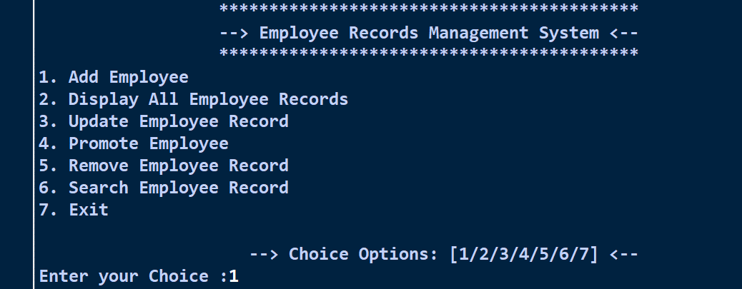

- Adding Employee

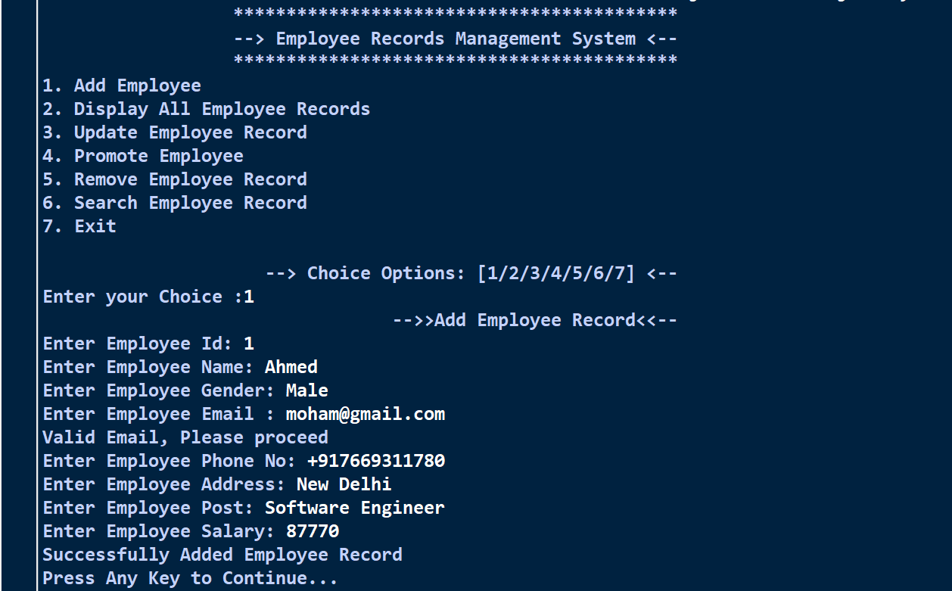

- Displaying All Records

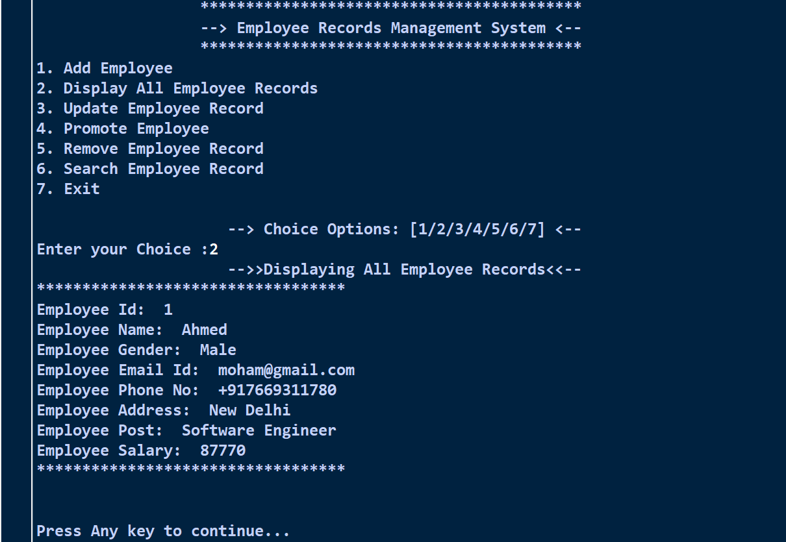

- Updating Employee Record
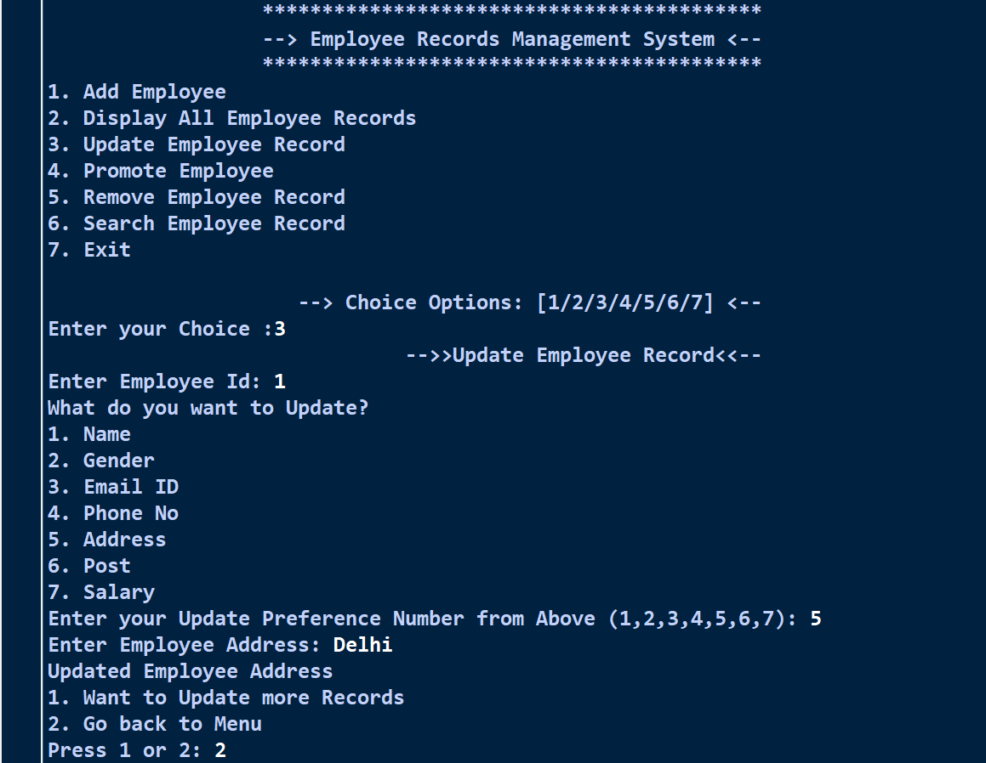

- Promoting Employee
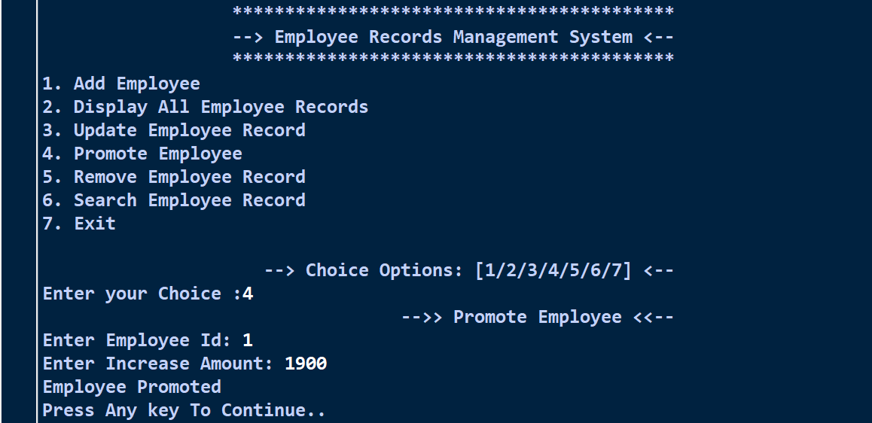

- Removing Employee

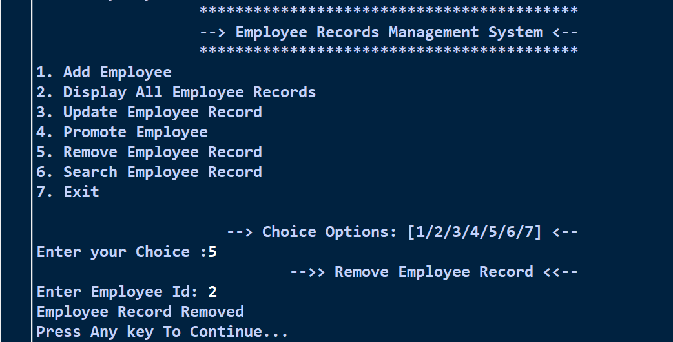

- Search Employee Record

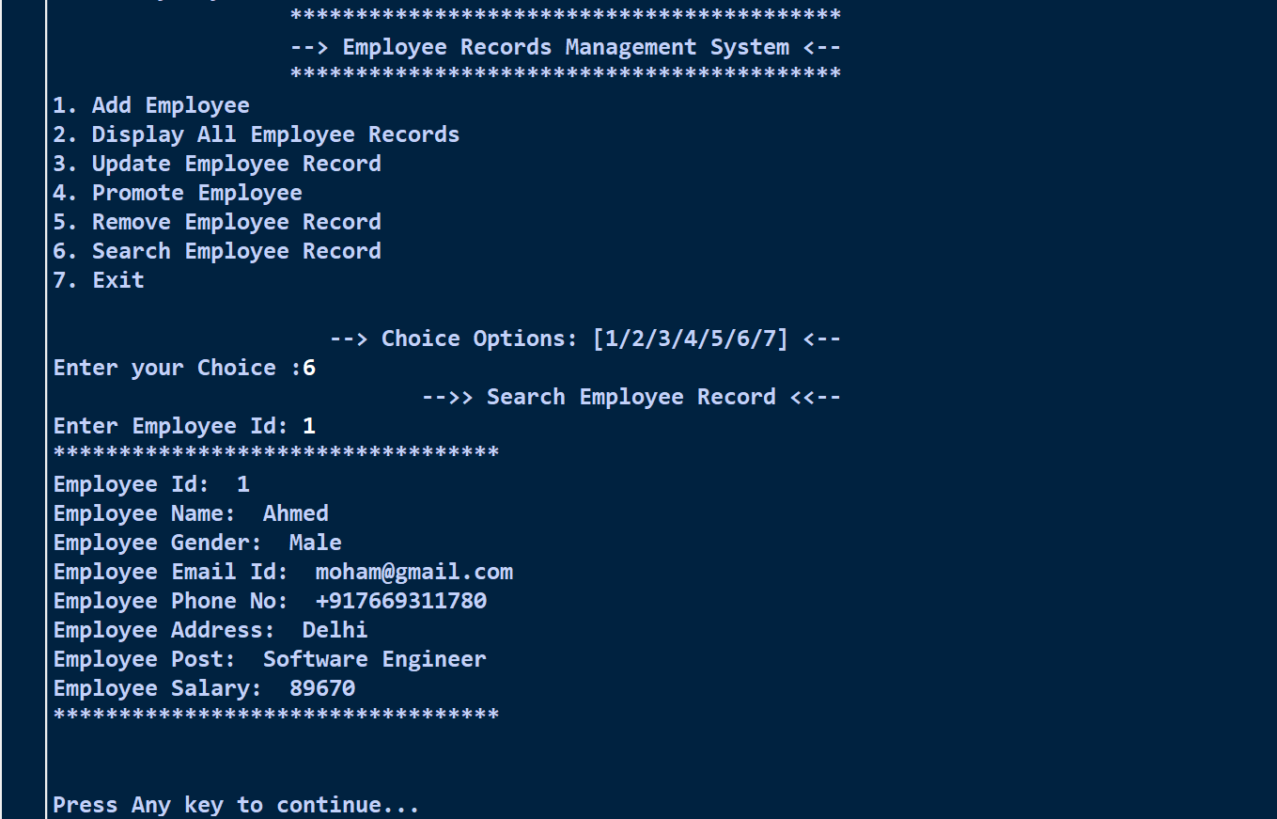

References
- Computer Science with Python Class XII by Sumit Arora.

- Stack Overflow -https://stackoverflow.com

- W3Schools –
https://www.w3schools.com

